**WCES**

**FUN PHYSICAL EDUCATION**

**MOVEMENT VIDEOS**

**FOR GRADES 3-6**

**SELECT ONE TO DO ON YOUR PHYSICAL EDUCATION DAY OR EVEN MORE AS YOU NEED MOVEMENT BREAKS THROUGHOUT A DAY.**

**BASKETBALL**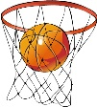

<https://www.youtube.com/watch?v=exLhf82Pcq0>

Waste Paper Basketball …Need a basket and paper crumbled into a ball

<https://www.youtube.com/watch?v=kw4D9iM8cDs>

<https://www.youtube.com/watch?v=J0M-ub50YH8>

<https://www.youtube.com/watch?v=HdVgiYTsJGc>

Advanced dribbling

**BASEBALL/SOFTBALL**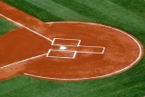

<https://www.youtube.com/watch?v=xeRNvz_Sdfg>

<https://www.youtube.com/watch?v=vQsV2QWjhOM>

<https://www.youtube.com/watch?v=S7xAHFhUG9k>

**BOXING WORKOUT**

<https://www.youtube.com/watch?v=pWLEkO0MlXs>

**DANCE**

<https://www.youtube.com/watch?v=MxlFGME_Hsk>

Trendy Dance Moves

<https://www.youtube.com/watch?v=jYFKtlBkspc>

Twist Zumba

<https://www.youtube.com/watch?v=TgcwKrf8wHM>

Can’t Stop this Feeling Dance

<https://www.youtube.com/watch?v=JbxDwaGwi2Q>

The Jailhouse Rock Dance

<https://www.youtube.com/watch?v=YGNLYGrZbzQ>

The Fight Song

<https://www.youtube.com/watch?v=EeajiJvW6B4&list=PLCpk5kxO81-ltOrLzGSt7lJnKiQX8Ifm4&index=5&t=0s>

Chocolate Dance

<https://www.youtube.com/watch?v=zQIBVCPTHaU&list=PLCpk5kxO81-ltOrLzGSt7lJnKiQX8Ifm4&index=3&t=0s>

Avocado Dance

**FITNESS WORKOUT**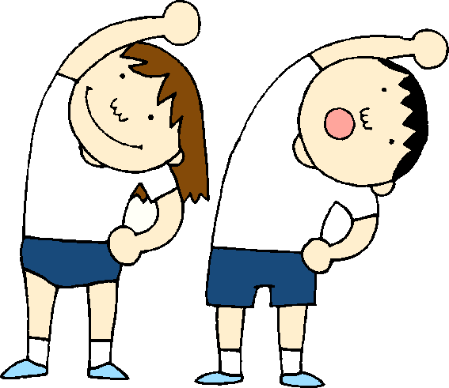

<https://www.youtube.com/watch?v=dkOIblknpUw>

<https://youtu.be/QeuI9XEGeZc>

**Need UNO cards**

<https://www.wevideo.com/view/1614233931>

Need two paper plates, two pieces of cardboard, or two wash clothes

<https://www.youtube.com/watch?v=X877ABbXVzE&feature=youtu.be>

**Need dice**

**FIELD HOCKEY**

<https://www.youtube.com/watch?v=3oIWk5qhlC0>

Field Hockey rules to understand the sport

<https://www.youtube.com/watch?v=Zi8lIzZLWt4>

<https://www.youtube.com/watch?v=2HknbpzEOhw>

**JUMP ROPE TRICKS**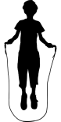

Needs a short rope and space to safely twirl

<https://www.youtube.com/watch?v=PUWg7fXnCf0>

<https://www.youtube.com/watch?v=PUCQ2pvnyW4>

**MINUTE TO WIN IT FAMILY FUN:** 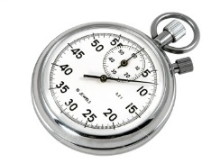

<https://www.youtube.com/watch?v=GSRgN0zpsMk&t=73s>

<https://www.youtube.com/watch?v=XEGQSjsNyW8>

<https://www.youtube.com/watch?v=2thishNxj-g>

<https://www.youtube.com/watch?v=Cu8angrhVLo>

**SOCCER**

**Needs a soccer ball and safe space**

<https://www.youtube.com/watch?v=2N5cWphNgiE>

<https://www.youtube.com/watch?v=bATaDzDD_mI>

**VOLLEYBALLC:\Program Files (x86)\Microsoft Office\MEDIA\CAGCAT10\j0301480.wmf**

Needs a volleyball and safe space

<https://www.youtube.com/watch?v=m-wtwOERx_Q>

<https://www.youtube.com/watch?v=LPrepLxqw3o>

**WALKING WORKOUTS INDOORS** 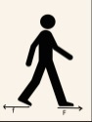

<https://www.youtube.com/watch?v=iBAjNQODSVo>

<https://www.youtube.com/watch?v=tW9IY48x1bc>

<https://www.youtube.com/watch?v=BunBLMgPhyk&list=RDCMUCVl6ZdslZz2Zj-34bMJFPbg&index=2>

**YOGA, MINDFULNESS, and VISUALIZATION**

<https://www.youtube.com/watch?v=rt1bsoOukjI>

Yoga Poses

<https://www.youtube.com/watch?v=7kgZnJqzNaU>

<https://www.youtube.com/watch?v=-6erFaJZqP4>

<https://www.youtube.com/watch?v=ZutNtWqrjX0>

Mindfulness Breathing

<https://www.youtube.com/watch?v=hjCrnwbkx-A>

What is Visualization?

**CREATED BY: MS. RYZEWSKI, WCES PE/HEALTH TEACHER**